Logic Development Assignment

1. Check entered number is Armstrong or not.
2. Given an any integer number i.e.- 5678. Write a program that displays the number as follows: 5678 678 78 8
3. Convert decimal number into Roman number (ie. 2- II, 10-X, 2014-MMXIV)
4. Find the second fastest runner person’s name and time. (Do not use database/query)

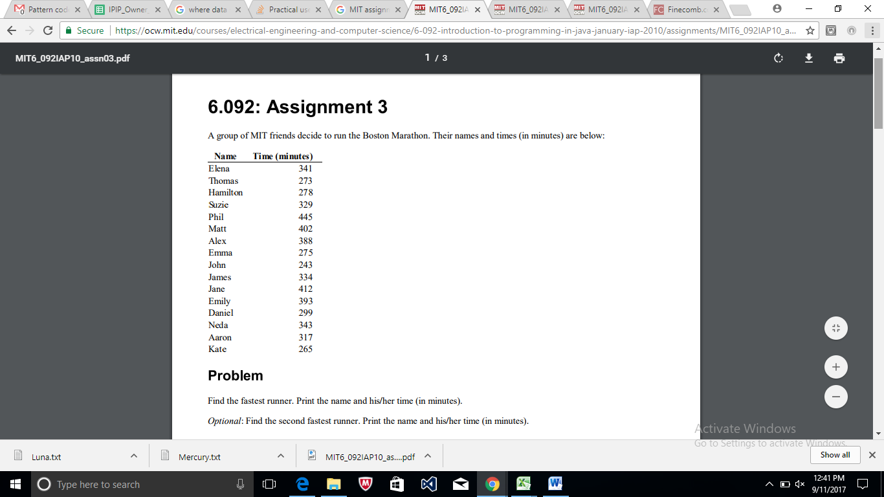

1. Write logic for Magic square. Enter any n digit and find summation of row, columns, diagonals etc. sums are equal. i.e for 3x3 magic square is display as:

